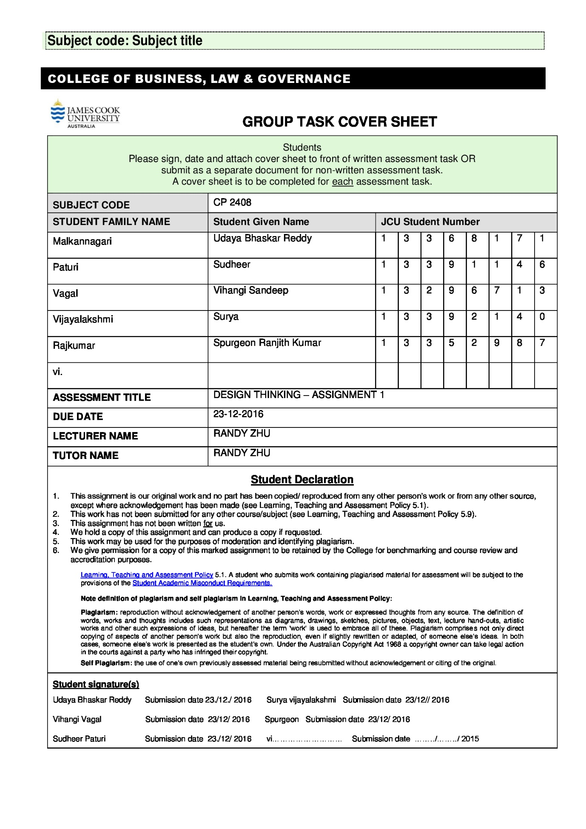

**CP2408 Assessment 1: Initial Project Plan**

**Team Members:**

**Udaya Bhaskar Reddy**

**Sudheer Paturi**

**Vihangi Vagal**

**Surya Vijayalakshmi**

**Spurgeon**

**Challenge 3:**

A supportive tool to aid new immigrants to Australia to acclimatise to living in Australia

Every year, over 190,000 migrants move to Australia with the purpose of building a life here. Of that number almost 14,000 are refugees. For some of these migrants, the Australian culture and lifestyle is very different to what they are used to. Your team’s job will be to develop a product that supports this initial “settling in” process. You are open to focus on nearly any aspect of this acclimatisation process as long as it is respectful. Be aware that currently immigration (what the Australian government calls migration) is a bit of a sensitive issue.

**1.Choosing the Design Challenge:**

When conducting a human-centric design thinking process, the first step involves the understanding of the user. It forms the centerpiece for the whole process and carries our purpose to the end. When choosing the challenge of the immigrants, our team placed ourselves in the user’s shoes and tried to analyze the issues they would encounter in the initial stage of their settling in process. It was easy for our team to identify ourselves with the users as most of us are foreign nationals studying in a different country. We could easily relate ourselves with the users in this challenge. Furthermore, this challenge offers a wide range of options to explore and analyze. We started with some preliminary research on the task set and brainstormed about the different aspects of the life of an immigrant and the issues which might be of a concern to them.

Our target group are the immigrants in Singapore. The group stressed on the importance of analyzing the basic needs of these immigrants .If we can address one of their core issues for settling in a new place with the aid of a supporting tool, we will consider this project a success.

Our long term goal and the project questions are explained in the section below.

**2. Long-term goal and project questions:**

***Long term goal:***

The long term goal of this project is to develop a product that enables a smooth progress in helping the immigrants in the initial phase of their “settling in” process.

We have looked at a multitude of options that can be considered in this regard. We brainstormed through a series of questions that will help us find solutions to the issues the immigrants face and help us design an aiding tool to address their core issues.

***Project Questions:***

Who are our immigrants?

What age group do most of the immigrants fall into?

Are the immigrants proficient in English?

Do the immigrants have basic knowledge to use smartphones?

What kind of work do the immigrants do?

What are the basic needs and necessities of an immigrant in an everyday life?

Are they comfortable with communicating with locals?

What are the initial hurdles he/she encounters during this phase of “settling in”?

What are the various ways we can address these core issues?

What kind of support can we provide to the immigrants?

Is there an actual need for a support tool to help ease this process?

How can we choose the best way to support the immigrants?

Who are the stakeholders we need to involve during the process?

What are the various technologies that can be used during this process?

Are there other better tools in the market? If so, why would the immigrant choose our aiding tool?

Are there any additional requirements that need to be considered while making a supportive tool immigrant-specific?

What are the steps to be taken to make the end product more user-friendly?

How do we know if the supportive tool meets our initial goals?

After creating a list of questions, we created a project map that will help us layout the summary of all the issues an immigrant faces on a single page. The map is like a guiding tool for us to identify all of the core issues in a single frame. We concentrated on the points which are of initial concerns to the user, in this case the immigrants. We realized that the basic needs of an immigrant revolves around some key central issues like finding a job, a place to stay and eat. We analyzed that social connectivity is also an issue of prominence since it deals with the emotional wellbeing of the immigrant and that issue needs to be addressed. We tried to look at the other ‘actors’ involved in providing solutions to these issues. In this case, the Government(/Employers) can be a stakeholder as it offers jobs. The housing agents can be stakeholders as they help the immigrants find a place to stay and the local communities can be stakeholders as they can offer the immigrants advise and guidance on certain issues. They may also improve social connectivity. Our team believes that social networking is an important tool for the physical and the emotional wellbeing of any person, and it is of paramount importance to an immigrant in a foreign land.

The project map is displayed in the section below. The stakeholders are represented on the left hand side.

**Stakeholders:**

* Government(Employees)
* Immigrants
* Housing Agents
* Locals

**Immigrant issues**:

* Finding an accommodation
* Finding a job
* Finding a place to eat
* Social Connectivity

**Goal**:

* Help the immigrants settle in.

**3. Project Map:**

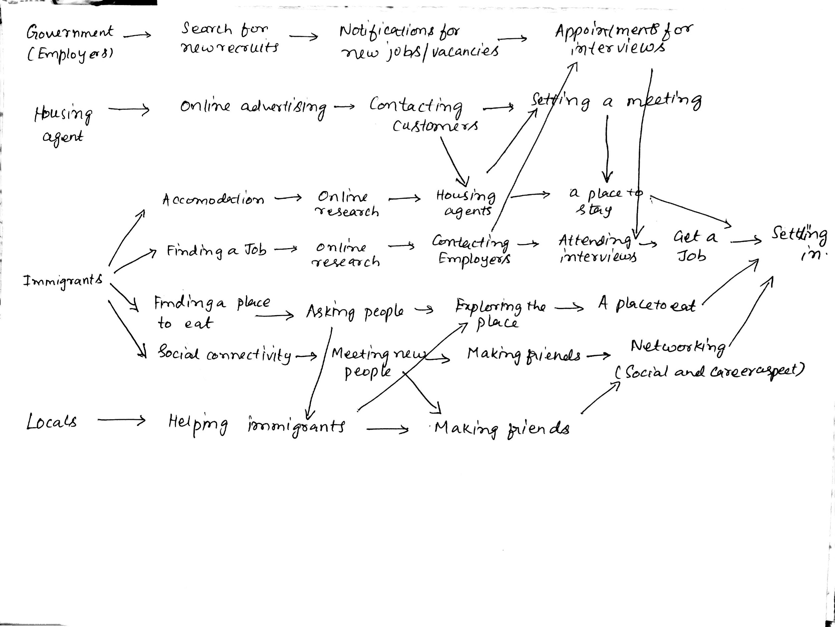

**4- Declaring Assumptions:**

After creating the project map, we analyzed all the core issues we identified in it. The issues have been summarized in the project map However, the challenge now was to pick an issue that needs to be addressed on an immediate basis. Our group brainstormed through a series of scenarios by looking at the issues from the immigrant’s perspective. We asked ourselves, what was our basic necessity when we came to a foreign land. And we had our answer, our immediate need was we needed a roof to live under, a place to stay!

We also looked at the other options available like finding a job and a place to eat. Our group felt that they are of equal importance, but the housing issue is a topic that found resonance in our group. As most of us faced the same issue when we came to Singapore, it was a personal preference for us. We brainstormed through a series of questions that will help us create a tool in aiding this process. Our first idea was to design a website that will help the immigrants find a house. We researched through several housing websites to understand the basic features implemented in them. We made a list of all the possible features that have been incorporated. It was a learning process in itself. However, we felt that making an app will also be an efficient way of reaching out to the users. As we believe that users across the globe, and especially in countries like Singapore, have a penchant for smart phones. They are well versed in their usage as well. And so, after a series of long discussions, and considering the pains and gains of the users in general, we arrived at our final product, and that is to make a housing app for the mobile phones.

We made a set of assumptions about the product we are going to make. We went back to our basic book of understanding, putting ourselves in the user’s shoes, and listed out all the possible assumptions that deals with the issues of an immigrant. The assumptions are listed below.

· The immigrants have access to smartphones as most people in this globalized world are dependent on smartphones to communicate with each other.

. The immigrants may have access to the internet to do online research or search for jobs and houses.

· They may have a language barrier when communicating with the locals because the majority of them come from Non-English speaking countries.

. The immigrants may have special eating habits, and prefer ethnic food.

· The immigrants may not be accustomed to use the local transportation as they are not familiar with and may find it hard to reach their workplace or make appointments on time.

· We believe they may have to take note of their family issues like their children’s education into consideration when they rent a place. Does it have easy access to their child’s school?

· The immigrants may want to rent/own a house that is close to their workplace, so that it will save them time and money.

· We believe they would prefer to stay in a neighborhood where there are people of his own community and it is easy to interact with people from their own ethnic groups.

· We believe they would want to live in residential estates where the noise level is low.

· The immigrants may need help and advise for searching for a house or other places from other locals as well.

**5. Outcomes:**

After creating the list of assumptions, we focused on the outcomes and the hypothesis that enables us to test the assumptions. We used the Lean UX format of table during this process. We identified the outcomes in the form of key performance indicators. We also created 3 proto-personas, that is explained in the sections below.

1. Immigrants prefer to live in areas populated with their own ethnic groups, because it will help them settle in the place easily, and they will also have easy access to their own local commodities and goods which may be available in other places. This actually quickens the settling process.

**Key Performance Indicator:**

In Singapore we have a large concentration of indian populace living in areas like Little India which are concentrated with the people from their own ethnic back ground. The goods and commodities available there are largely based on the preferences of the indian populace. The same can be applied to areas like Chinatown, etc., This shows that people tend to prefer living within their own communities in a foreign lands. There can be many benefits out of it like having access to native goods and amenities, easy communication with people(for non-English speakers) etc., This factor can also be measured by an increase in the number of signups to the community clubs within the area.

1. Housing agents can be an effective medium to help the immigrants find houses quickly and more efficiently. For a new immigrant settler, doing online research and finding a house can be a hassle. There is also a chance of being cheated by fake agents by having to pay huge amounts in advance. With the help of registered agents, they may be able to find a house that suits to their needs. (Registered agents refer to the agents who work under an authority, it can be a Government or a private agency)

**Key Performance Indicator:**

This can be measured by using the data of all the house bookings made by immigrants on behalf of the registered agents over a period of time.

1. Immigrants prefer to use public transportation to their workplaces. It will help them financially in the initial phase of their settling in process.

**Key Performance Indicator:**

This can be measured by conducting surveys about the number of immigrants who use/not use their own vehicles to reach their workplaces.

1. Immigrants can socialize easily with the members of their own country.

**Key performance indicator:**

This can be measured by an increase in the number of membership at the immigrant specific community clubs over a given period of time.

**6. Hypothesis:**

|  |  |  |  |
| --- | --- | --- | --- |
| **We believe that**  **(doing/building/creating)** | **For this**  **user/persona** | **Will result in**  **(this outcome)** | **And we’ll know we’re right when we see**  **(this signal/metric)** |
| We believe that having a app is helpful for | immigrants | More number of people using the app | Increase in the app downloads |
| We believe that incorporating agent contact info in the app will help | immigrants | Immigrants contacting agents directly for accommodation | An increase in the count of bookings made through the agents |
| We believe that helping people to find a place near their ethnic community is essential for | immigrants | Faster settling of the immigrants | An increase in the user selection of the area options in the app |
| We believe that incorporating language options in the app | immigrants | More non-english speaking immigrants using it | Increase in the language selections in the app |
| We believe that enabling people to find a house near their workplaces is beneficial | immigrants | Easy access to the workplace | Decrease in the number of people using own vehicles to reach the workplaces |
| We believe that enabling only registered agents to use the app is essential for | immigrants | Filtering out fake agents | Users approaching registered agents multiple number of times, which can be evaluated in the app |
| We believe that enabling people to settle in residential areas is essential for | immigrants | People renting homes in residential areas | Growth of people in the residential area, accessed by the residential lists. |
| We believe that enabling people to settle near places to eat | immigrants | People having easy access for a place to eat | Increase in revenue of the local food joint owners |
| We believe that enabling people to settle near ATMs and banks | immigrants | People having quick access to money | An increase in the immigrant bank accounts |

**7.** **Proto-Personas**

**Persona 1**

**Richard Jones, Web Designer**

**Demographic/Personal information**

**Age: 26 years**

**Nationality: British**

**Marital status: Single**

**Languages spoken: English**

**Housing preference**

· Single bedroom studio apartment

· Residential Area

· Near Raffles (close to workplace)

· Carpark

**Activities/Hobbies**

**·** Swimming

· Reading

· Travelling

· Visits nightclubs/bars

**Persona 2**

**Linda lee, Interior designer**

**Demographic/Personal information**

**Age: 31 years**

**Nationality: Chinese**

**Marital status: Married with 2 kids**

**Languages spoken: Mandarin, Cantonese**

**Housing preference**

**·** 3-bedroom apartment

· Within $2500 per month

· Close to kids’ school (Chinese International school)

· Easy access to public transportation

**Activities/Hobbies**

**·**  Cooking

· Shopping

· Jogging

· Gym

· Bringing kids to playground/Park

**Persona 3(outlier)**

**Zaki Azmi, Gym instructor**

**Demographic/Personal information**

**Age: 43 years**

**Nationality: Malaysian**

**Marital status: Single**

**Languages spoken: Malay, moderate English**

**Housing preference(temporary resident)**

· Master room only for one year(short term settlement)

· Close to workplace

· Close to Singapore-Malaysia checkpoint

**Activities/Hobbies**

**·**  Sports (Soccer Swimming)

· Guitarist

· Movies

**8. Problem Statement:**

We have observed that the current housing apps that are available in the market are not meeting some criteria’s that immigrants consider when looking for an accommodation. We want to solve this problem by designing an immigrant specific mobile app that helps them in their settling in process.

**9.Features:**

After going through the hypothesis and creating a problem statement, we came to the stage wherein we can address all the issues identified with the features that will be incorporated in our product. We listed all the features that form the core of our product. The features are explained below.

**Features :**

**Foreground features:**

* **App language:** We provide all the features of the app in various languages, so that it’ll be easier for the user to understand the menu and navigate through it. This feature will be beneficial to the non-english speaking users.
* **Nearby:** We have a feature in our app that shows all the nearby facilities. Things which can be expected are:
* For easy transportation:
  + MRT
  + - LRTs
  + - Bus stops
* Amenities:
  + ATMs
  + Banks
  + Restaurants
  + Food court
  + Malls
  + Community Centers

**Housing preference:** This lets the user browse through all the accommodations that are available within the app and also they would be able to contact the registered agent for that property, if they want to rent it or own it.

* **Filter by location:** This feature displays houses which are nearby to the preferred school or workplace.This makes it easier for the users to chose the house.
* **Maps:** The maps are google maps representing the location of the house and also the nearby food court, mrt .It will also redirect you to the google map once you click on it and will provide you directions to reach the house.
* **Weather updates:**  A weather update will be provided which provides the user with a detailed weather report which includes the description for each season, i.e,the months when that particular season will occur, and accordingly what precautions to take during that season.It also potrays the daily weather forecast.
* **Contacting:** We provide real-time chat interface between the user and the company. This will be helpful for the users to clear their doubts.

**Background features:**

* **Registered and verified user:** We make sure that we don’t provide wrong information. To make it sure, we have all registered and verified agents. In order to publish property posts the agent must have registered an account with their agency’s email id, their license or permit number. The details provided will be sent to the agency, upon approval from the agency the agent is given access to the application to publish property post.

**10.** **Team Collaboration Plan**

* **Team Configuration**:

Team Leader: Udaya

Team Members: Sudheer

Spurgeon

Vihangi

Surya

Uday

* **Team Approach**: After discussing among ourselves on which topic to choose, we selected the Challenge 3. In our first meeting, each of us shared our opinion about the project and how we should approach it, the ways, the means and the rules of the approach. We decided on some ground rules to deal with team meetings(when and where we should meet), team collaboration on what topics each one of us are good at, and also we discussed about the behaviour of the team when/if a conflict arises during the working of the project.
* **Communication**: Most of the team communication is done through Whatsapp and through Email. We decided to use Whatsapp as the preferred communication method as it is the best available option for the interoperability of the team. After each meeting, a word document, which consists of all the things we discussed in that meeting is sent to every individual in the team. We did this to make sure that the information is readily available with every member of the team.
* **Information sharing:** Vihangi (one of the members) created a Google Docs file and added every team member’s email id to it, so that we can edit and write the content for the assignment at any time required. We constantly updated the file with the new information and points we discussed during the meetings. We decided Google docs would be the best cloud sharing option as it can synchronize data in real time even if all the team members are using it all at the same time.
* **Team Progress:** During our first meeting, we discussed on how to check the progress of the team and also of the individual selves. We decided to use Google calendar to create events about the next team meeting and added all the members of the team to it, so that they would be reminded of the meeting in advance. We set the date for the second meeting during our first meet, and we did the same for the third meeting by deciding the date during our second meet, and same for the fourth meet. This helped us in achieving smooth collaboration among the team.

* **Team Rules:** We laid some ground rules for the team in the first meeting about the common problems of team, late for meeting, cannot attend meeting, work style, willful participation and some other common issues.
* If a member of the cannot attend the meeting, he/she should convey that at least a day before, so that we can schedule the meeting at an appropriate time.
* If a person is late for the meeting, he/she should catch up on that during their own time and should be in the sync of the progress.
* In case of Homework, all files must be uploaded in Google Drive no later than 8pm the day before the meeting.
* If one of the group members is sick,the tasks given to him/her will be distributed among the other group members.
* Skype meetings are allowed, if the group agrees upon.
* It is expected that all members attend class on regular basis.
* Each member will agree on the answer for each group problem before it is turned in. ln circumstances where agreement is not automatic, each member shall explain how they arrived at their particular solution until a correct solution is clear. If no agreement can be reached, a vote will be taken on which result to submit.
* I will do everything in my capabilities to help my fellow group members understand each and every concept and problem.

These are some of the rules we set up for the team.The team rules and culture are illustrated further as listed below.

* **Conflict Management:** When working in a team, a conflict is inevitable. We as a team had some conflicts among ourselves, but we got through that phase and are working towards achieving our set goal. Most of the conflicts are regarding an idea or a topic that some of the team members cannot agree upon, or cannot fully understand. These are mostly debates among ourselves. And this is a good thing actually. This kind of situation, after it is resolved would make us think and approach the problem from a different perspective. A new way of thinking is the first step towards innovation. It will also help us achieve our goals in a competitive manner. Our team leader tries to explain the question more and clear, in such a way that it will reduce the tension in the group and also help us focus. If that cannot resolve the issue, we approach the lecturer to get his opinion on the topic/idea.

**Personality Tests : Defining the roles**

**Reference :** [**https://www.16personalities.com/free-personality-test**](https://www.16personalities.com/free-personality-test)

Our team used the personality tests to identify the strengths and weaknesses of each member within the group.We used the referenced website as a tool to analyse each of our character traits.The results are illustrated below.

**Surya:**

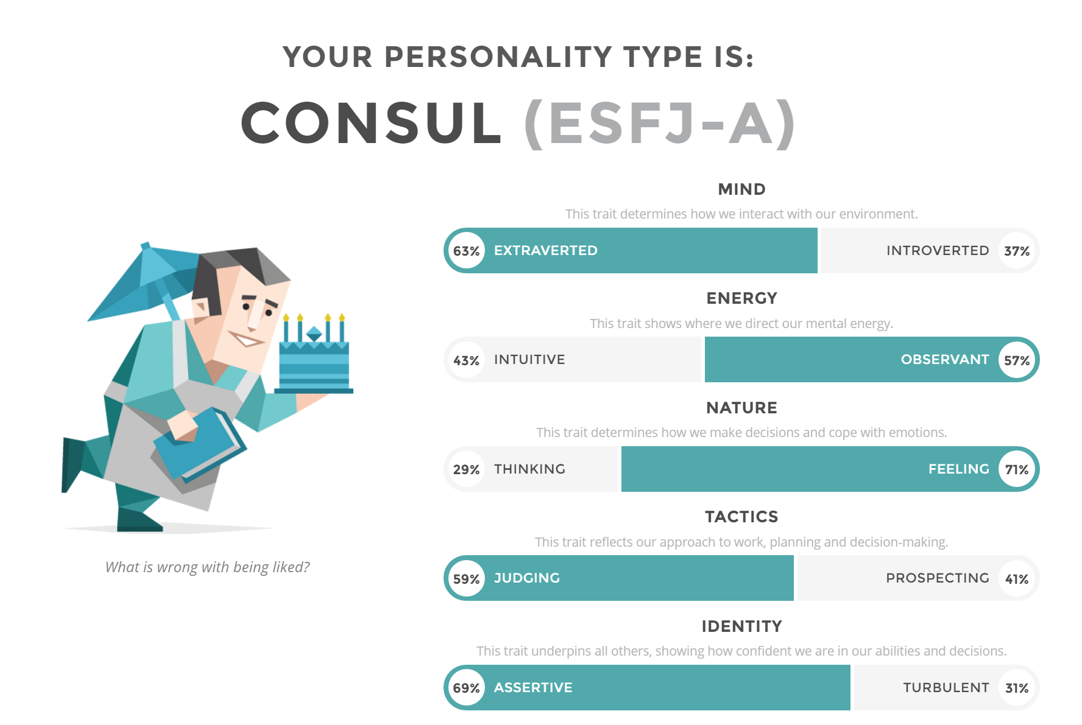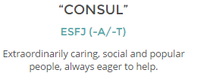

Team player Surya comes under category “Consul”. People in this category are highly assertive. They feel and judge a lot. They are extraverted personalities with observant attitude.

**Vihangi:**

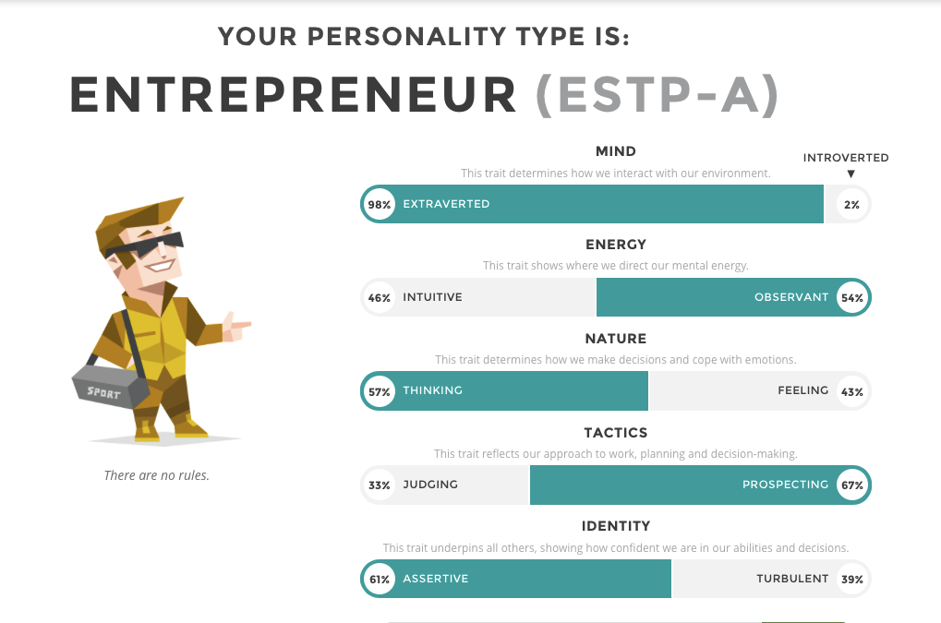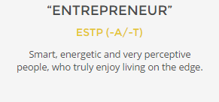

The team member Vihangi comes under the category entrepreneur. As the people in this category are considered to be smart , energetic , and interactive people, it will beneficial to the team. The team members can easily express their ideas and she can help in taking smart and quick decisions.

**Spurgeon:**

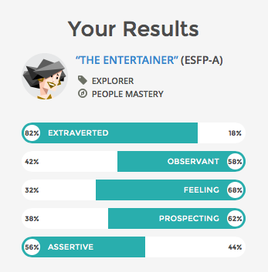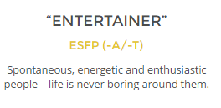

The team member Spurgeon comes under “Entertainer” category. People who come under this category are good team players and they give equal opportunity and respect for others opinions and suggestions. They are optimistic and since they are highly assertive they would guide the team in progress while providing their full help.

Through these strengths and weakness of each player we have formed a team collaboration plan which will benefit the team.

**Uday:**

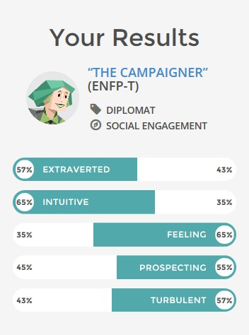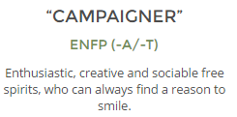

Team player Uday comes under “Campaigner” category. People in this category are highly enthusiastic and social. They would make good team leader as they are diplomatic. They are creative and prefer to do hands on work.

**Sudheer:**

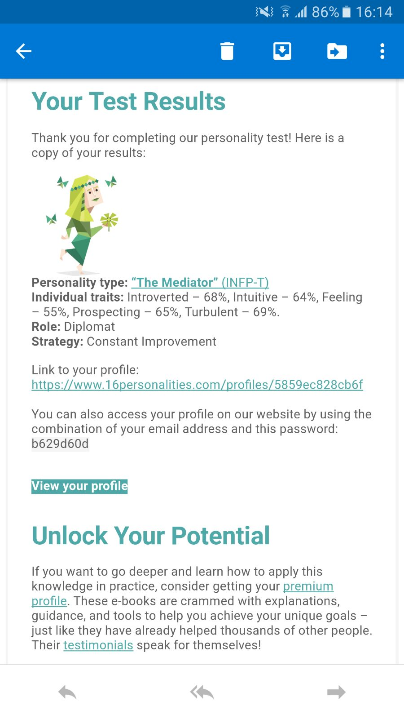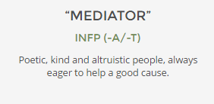

Team player Sudheer comes under “Mediator” category. People in this category are highly instinctive and they would apply their knowledge in practice and would come up with sensible ideas. They believe in constant improvement.

**Mobile App functionality:**

All the features and important functionality of our mobile app is summarised in this paragragh. Our mobile app provides necessary information and guidelines for new immigrants coming to Singapore. This app precisely focuses on properties and accommodation that renders to immigrants in short notice. The app supports the entire campaign for property developers from advertising to sales while having the focus on the benefit of immigrants. It eliminates gimmicks and fake property agents while allowing clients to connect via real-time chat and email to collect complains and feedbacks. The Project crew clearly monitors the communication between agents and clients and steps in, in need of assistance. The project would provide the closest match to the preference of the clients and guarantees the best service possible. The app itself will get regular updates and new implementations to stay updated and relevant. All of this in combination would create a good reputation among new immigrants which will expand our business.

We believe we have identified the key features for making a minimum viable product and put it into a working solution to help the immigrants in their settling in process.

**12. Project Meeting Schedule and Objectives:**

**Meeting Schedules:**

|  |  |  |
| --- | --- | --- |
| Topic | Plan | Objectives (<50 words) |
| The project topic | Date :8th December 2016 Time: 2:00 pm to 5:00 pm  Venue : Student Hub | Decide which topic the team will work on |
| Long term goals and project map | Date :12th December 2016 Time: 6:00 pm to 7:30 pm  Venue : Student Hub | The long term goals for the project and create a project map |
| Assumptions and outcomes | Date :15th December 2016 Time :2:00 pm to 5:00 pm  Venue : Student Hub | Discuss and list down all the assumptions. Using the assumptions , make a proto-persona and note down the outcomes. |
| Hypothesis statement, problem statement | Date : 19th December 2016 Time :12:00 pm to 2:30 pm  Venue : Student Hub | Form the problem statement based on the hypothesis and outcomes |
| Features | Date :20th December 2016 Time : 5:00 pm to 7:00 pm  Venue : Student Hub | Discuss the features . |

**Minutes of the meeting 1:**

**Name of Team: RisingSun**

**Date of meeting:** 8th December 2016 2:00 pm to 5:00 pm

**Members present:** All team members

**Members absent:** None

**Meeting chairperson:** Uday

**Minutes taken by:** Surya

**Summary of meeting:**

The three challenges, i.e., the topics for the project were revealed by the lecturer. We discussed each topic. The discussion included which topic had a broader perspective and the one on which we could work together. After a long discussion we note down the view of each team member and deciding to opt for challenge 3. As most of the team members are international students we believed we could relate more and give more inputs in challenge 3. We concluded the meeting with noting down the rules of the team.

**Action items for Team members:**

|  |  |  |
| --- | --- | --- |
| Actions to Do | Who will do this work? | By when? |
| Create a google document | Vihangi | Same day |
| Research on the topic | All team members | Next meeting |
| Complete the personality test | All team members | Next meeting |
| Typing the team rules | Sudheer | Next meeting |

**Next meeting date and time:** 12th December 2016 6:00 pm to 7:30 pm

**Minutes of the meeting 2:**

Name of the Team : **RisingSun**

Date of meeting: 12th December 2016 6:00 pm to 7:30 pm

Members present: All team members

Members absent: None

Meeting chairperson: Sudheer

Minutes taken by: Uday

Summary of meeting: (what has been discussed, decisions made)

The meeting started with a discussion and brainstorming session. We formed the long-term goal. We then listed down the questions that using the long term goal. We even interviewed a few international asking them their opinion about what problems can the immigrants face when settling in Singapore. We made a board with sticky notes. The sticky notes contained answers to each of these questions we received from the interview. Using these answers, we created a draft project map indicating 4 major issues the immigrant might face while settling in.

Action items for Team members:

|  |  |  |
| --- | --- | --- |
| Actions to Do | Who will do this work? | By when? |
| Form the final project map | Uday | Next meeting |
| Research about the problems the immigrants will face during settling | All team member | Next meeting |
|  |  |  |

Next meeting date and time: 15th December 2016 2:00 pm to 5:00 pm

**Minutes of the meeting 3:**

Name of the team : **RisingSun**

Date of meeting: 15th December 2016 2:00 pm to 5:00 pm

Members present: All team members

Members absent: None

Meeting chairperson: Vihangi

Minutes taken by: Spurgeon

Summary of meeting: (what has been discussed, decisions made)

The meeting started with going through the project map. We conducted another brainstorming session where a list of assumptions was listed. We picked each category from the project map and listed about ten assumptions. After which, we short listed ten assumptions which are important. These list of assumptions lead to forming a list of outcomes. Each of discussed and contributed our ideas for the proto-personas.

Action items for Team members:

|  |  |  |
| --- | --- | --- |
| Actions to Do | Who will do this work? | By when? |
| Form drafts of proto-personas | All team members | Next Meeting |
| Type the assumptions and outcomes which were decided during the meeting | Spurgeon | Next Meeting |
|  |  |  |

Next meeting date and time: 19th December 2016 12:00 pm to 2:30 pm

**Minutes of the meeting 4:**

Name of Team: **RisingSun**

Date of meeting: 19th December 2016 12:00 pm to 2:30 pm

Members present: All team members

Members absent: None

Meeting chairperson: Surya

Minutes taken by: Vihangi

Summary of meeting:

The meeting started with editing the personas and forming three final ones. Then using these personas we discussed the what problems could the immigrants face and what are their requirements. Then we formed these into hypothesis statements and problem statements.

Action items for Team members:

|  |  |  |
| --- | --- | --- |
| Actions to Do | Who will do this work? | By when? |
| Research the ways to solve the problems of the immigrants | All team members | Next meeting |
| Type the hypothesis statement and problem statements discussed | Vihangi | Next meeting |
|  |  |  |

Next meeting date and time: 20th December 2016 5:00 pm to 7:00 pm

**Minutes of the meeting 5:**

Name of Team: **RisingSun**

Date of meeting: 20th December 2016 5:00 pm to 7:00 pm

Members present: All team members

Members absent: None

Meeting chairperson: Spurgeon

Minutes taken by: Sudheer

Summary of meeting:

In the meeting we discussed different way we could solve the problems of the user. We made a chart with listing down solutions to each of the problems we assumed the immigrants might face. The meeting concluded with listing down features.

Action items for Team members:

|  |  |  |
| --- | --- | --- |
| Actions to Do | Who will do this work? | By when? |
| Note down the features | Surya | 22nd December 2016 |
| Complete the assignment 1 | All team member | 22nd December 2016 |
|  |  |  |

Next meeting date and time: --

**Secondary Research Notes Template:**

|  |  |  |
| --- | --- | --- |
|  | **Source** | **Insights** |
| 1. | http://www.migrationpolicy.org/programs/migration-data-hub?gclid=Cj0KEQiAkO7CBRDeqJ_ahuiPrtEBEiQAbYupJd77Kn4FA2PjkWTbwndqssaHEJd1948nnMSO0VorzOsaAoqO8P8HAQ | Immigrant data |
| 2. | https://en.wikipedia.org/wiki/Immigration_to_Singapore | Immigrant condition and status in singapore |
| 3. | http://www.singstat.gov.sg/statistics/browse-by-theme/population-and-population-structure | Population data |
| 4. | http://www.modelparliament.sg/the-challenges-of-immigration/ | Challenges that immigrants face |
| 5. | http://www.straitstimes.com/singapore/no-easy-choices-on-foreign-worker-immigrant-policies-pm-lee | Foreign workers in singapore |
| 6. | http://thediplomat.com/2014/02/singapores-foreigner-problem/ | Racial tensions in sinagpore |